Black Dog Theatre Creation Project Evaluation: Teechers

A Black Dog Theatre Creation specifically designed to work with 18-25 year olds

Introduction:
Following the success of the Black Dog Theatre Creation Project, I was interested in exploring the idea of developing a similar project, but which was designed on focusing on supporting younger people with low confidence and poor self-esteem. The idea came about after I was approached by several parents and younger people requesting that I ran the Black Dog Theatre Creation Project for young adults. Many of whom felt that there was a gap in the local community for supporting younger people with mental health issues and poor confidence.

Over the six-month project I worked with a group of young people, exploring mental health issues specifically linked with young people using performance techniques during workshops. The project confirmed some of my ideas of depression among young people, but it highlighted many other issues and causes which I had not previously thought about. The participants were in the main much more forthcoming and open to using performance skills – particularly role-play, improvisations and movement and I found that using music as a stimulus to start discussions worked as a powerful opening. As an Artist, I learnt a great deal from the whole experience and it both strengthened and challenged my creativity.

Throughout the workshops and rehearsals, I noticed a great deal of change in the participants’ behaviour. Some were very apprehensive as to what they would gain from taking part and were anxious about the concept of performing in public. This behaviour was slowly replaced by a positivity and team work within the group and a determination in producing an excellent piece of theatre. The result was two sell-out performances and a special invite to perform at The Arts Theatre in London.

Success Story 1: Ruben’s Story
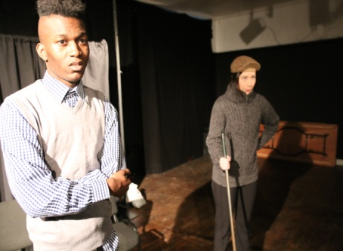
Hi, my name is Ruben and I first heard about the project from a post advertising it on Facebook. At first, I wasn’t sure because I didn’t feel very confident and at the same time, I didn’t want to be part of a group which would advertise the fact that I suffered from poor confidence. After chatting to Alfie, he reassured me, and I decided to give it a go. I hadn’t had any previous experience in acting other than bits in drama lessons when I was at school. After a while I started coming out of myself and Alfie taught us all to have more confidence in ourselves and he made it all fun. By using drama, we all relaxed and were able to become other people and to use role play to explore some of our own problems. It really helped. I really liked the improvisation games that we played, and Alfie was really patient with me in terms of my commitment and he helped me to develop my voice more so that people could hear what I had to say. The show was brilliant, and I couldn’t believe that Alfie had managed to organise for us to perform in a London theatre as a bonus. I’ve learn so much from this project and I can’t thank Alfie enough.

Artistic Outcomes:
Our Artistic aims were:

- Use drama and performance techniques to develop young people’s confidence, self esteem; independence and to encourage positive well being.
- To explore some of the stigmas and issues of mental health through drama techniques.
- Work with local Artists to develop/explore performance techniques which can support young people suffering from poor confidence, self esteem and mental health.
- Devise, rehearse and perform a theatrical piece at our local Arts Centre with a group of young people who suffer from poor confidence and self esteem.
- Create a free Educational pack for local schools, colleges and organisations to support their others with poor confidence and mental health issues.

In evaluating the outcome of these intended aims I have broken them down individually:

- Use drama and performance techniques to develop young people’s confidence, self esteem; independence and to encourage positive well being.
- Work with local Artists to develop/explore performance techniques which can support young people suffering from poor confidence, self esteem and mental health.

In our workshops we explored different performance techniques including role-play, improvisation, movement, mime, expressions and scripted pieces to develop confidence. We noticed the participants’ quickly becoming more willing to take part and getting up spontaneously to act out scenes and to try out new techniques. Through team work, drama games we strengthened the relationship between the group and each participant felt trusted and that they could trust others. (As well as themselves)

In our evaluation workshop it was reported that 100% of the participants felt that they have developed a significant amount of confidence, independence and felt happier and more positive within themselves.

- To explore some of the stigmas and issues of mental health through drama techniques.

We used our workshops to explore some of the stigmas attached to mental health and young people. Through discussions and drama activities we highlighted the lack of understanding and support for young people suffering from mental health issues. We explored situations and developed scenes to show some of the causes of mental health issues among young people before discussing possible solutions. In our evaluations our participants highlighted the effectiveness of using drama as a way of doing this as it broke down any uncomfortable feelings which may be felt and dealt with the issues raised in a sensitive manner. It was suggested that these skills could be used to develop an education pack of some kind for schools, colleges and universities to use as well as parents. Should we develop this project further we would like to consider putting this suggestion into practice?

- Devise, rehearse and perform a theatrical piece at our local Arts Centre with a group of young people who suffer from poor confidence and self-esteem.

Our performance of Teechers by John Godber was a central part of the project. The choice of play was made because it is a performance which success depends upon working as a team. There are a range of lots of different small parts which make it easy to adapt for a range of different casts and abilities. The choice was very popular among the cast and allowed for each member to challenge themselves independently. The play was fast paced and approximately an hour in length which was not too daunting for the participants. It included characters which every member could recognise and relate with.

The performance itself was hugely successful and was made even more special after we were invited to perform at The Arts Theatre, London West-End. This invite boasted the cast’s confidence beyond all belief and inspired everyone to want more and that anything could be achieved.

The feedback we received from audience members was wonderful and very positive. Questionnaires highlighted the opinion that the performance techniques used were hugely successful in supporting and developing confidence and positive well-being.

- Create a free Educational pack for local schools, colleges and organisations to support their others with poor confidence and mental health issues.

Sadly, we were unsuccessful in developing the complete education pack due to time. We however did use several of our workshops to discuss and explore the issues affecting those young people and their friends and families suffering from mental health. We did identify stigmas and through theatre skills we began to develop support mechanisms and positive ways of tackling some of these stigmas. We did begin to create some activities which we have shared with teachers to use in schools and we received some lovely feedback. If I continued to develop this project further I would very much like to continue to develop and to create an education pack to support schools/colleges/universities and parents.

Success Story 2: Frieda’s Story
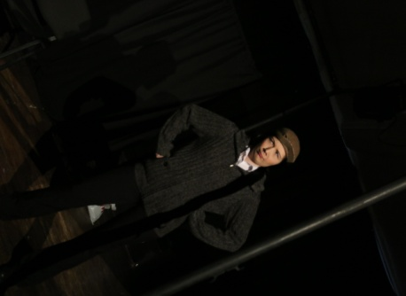
I have thoroughly enjoyed taking part in this project. From day one everyone has welcomed me into the group and I have enjoyed all aspects of the projects. English is not my first language and I was scared that this would be a problem, but Alfie quickly put me at ease and I have found that my speaking out in front of people has got so much better. I really enjoyed playing different characters in the play and showing lots of different emotions and moods. I really had fun developing facial expressions and body actions in our workshops. I thought that the idea of using theatre tools to help us all was a nice way to develop our confidence and get us up and forgetting our troubles. I got so much from performing on stage and now wish to take this further by acting more.

Public Engagement:
In terms of our Public Engagement we found that we were successful in getting together a group of young people from within the local community to take part. We did find that the best form of marketing the project was through both our website and using social media formats. What we had to be careful about was the wording of our engagement strategies as many of the participants were extremely sensitive to others labelling them as people with mental health issues or who suffered from low confidence problems. This highlighted the fact that there is still a stigma attached to those who suffer from these conditions within society which is perceived as being negative. An attitude which needs to be changed. We did find it incredibly difficult to engage with the younger end of our targeted audience in participants and most of our group were made up of late teens and early twenties.

Our links with local organisations and services was successful and positive. We have now created several new links with online support groups across social media sites which promote positivity and support young people with mental health or confidence issues. We have also strengthened our link with local theatres and created an amazing new link with the Arts Theatre, London whom were supportive with our project and are keen to continue developing our link in the future. By performing at an extra venue, we were able to develop an additional excitement and positivity with the participants as well engaging with a much bigger audience.

Each of our performances held an audience size of 30 and we successfully sold out two shows as well almost selling out the third. We received a great deal of positive feedback from our all our audience members and we were able to measure the impact and opinions from our audiences by our questionnaires and verbal feedback given after each performance during our meet and greet sessions.

What would we do next time?
If given an opportunity to further develop this project we would like to create further links with Colleges to successfully reach the younger end of our target audience. We would do this by running free one-off workshops in colleges to make it easier for Students to attend. We would also like to strengthen our link with the Student Union which would help us to engage with our targeted audience. We were disappointed that we were unable to engage with the local Youth Education Services during this project despite numerous efforts to engage with them and so this would be a new focus point to develop should we continue in the future.

Success Story 3: Jack’s Story
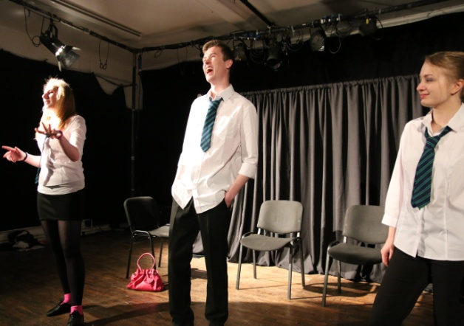
Since coming out as being Gay at school I have had a bit of a rough time with things and it’s knocked my confidence a lot – especially in developing socially in my own community. Where I live isn’t very accepting of my sexuality and I have been bullied repeatedly. I love acting and so when I heard about the project I thought it was an amazing idea. I knew of Alfie’s work with the Black Dog Theatre Creation project and knew that he was sensitive and didn’t treat us like we were animals in a zoo or precious bits of glass that could break at any time. The workshops were great and a lot of fun. It let me be myself freely and I made a lot of new friends and developed my confidence A LOT! By using acting it made everyone feel at ease and let people use role play and improvised scenes to explore their own problems in an unthreatening way which was good. He made us feel that we could respect ourselves and made us feel like we all had talents and could achieve massive things. Devising the play and then performing was my favourite aspect of the project. Although we took on a well-known play, we were encouraged to develop the characters ourselves and it made us feel like we had ownership over it all. I absolutely loved performing on stage (Especially in London!) and it’s given me the confidence and motivation to take it further. Although I still think that my local community has a big problem with who I am, I’m no longer afraid to be who I am within the community. I owe that to Alfie and this project!

Marketing the project:
Our marketing strategy took a slightly different direction to our previous Black Dog Theatre Creation projects. We knew that our target audience was different and would need to be engaged by using other techniques. We set out promoting the project through posters at specific areas such as Colleges and Universities. We then used social media, setting up a webpage and a Face-book and Twitter page specifically for the project. This proved to be very successful. We also advertised the project through acting websites such as Starnow.com.

One of our biggest problems was wording the project and the criteria. Many of the participants did say that they were apprehensive because of the stigmas attached to mental health. They didn’t want to be labelled and the name of the project did hinder this. Once we had considered this in terms of the font size of the wording and the language which we were using to market the project, we then found a greater positive response for the project.

Marketing the production was easier because we had already built several previous links and had nurtured strategies towards gaining success. One of the new strategies which we used whilst performing in London was to go out as our characters in costumes and acted out short scenes from the play whilst handing out leaflets to passers-by. This developed our confidence even further and was also great fun. By doing this in costume, it allowed the participants to feel safe because they were protected by their costume and weren’t necessarily being themselves. Still, at the end of the exercise they felt a great sense of achievement.

What would we do differently next time?
The main aspect which we would take better consideration towards would be the way in which we promoted the project in terms of wording. We would pay more particular focus to the actual performance which we were performing. This could read as:

TEECHERS
A Black Dog Theatre Creation

This would take the focus away from the Black Dog Theatre Creation aspect and further information can be shared once interest has been expressed. It would make potential participants feel more at ease in getting involved.

Overall Evaluation
The project was a great success and in many ways, it exceeded its expectations and generated larger outcomes than first anticipated. All of the participants and artists involved developed in confidence and creatively. The project has continued to demonstrate how affective theatre and performance techniques can be used as a strong tool to support the community and generate positive social and personal change.

The project has supported my own individual development as a Project Leader and Director. This project was very different to leading the other Black Dog Theatre Creation projects because it was tailored towards a more specific target audience. Working with younger people brought along a different set of challenges – some of which I had been naive in not anticipating and this has taught me a great deal in organisation and leadership. This was particularly apparent when marketing the project and engaging with the target audience. However, I found that in comparison with the other Black Dog Theatre Creation projects which worked with older people, the workshops were faster in pace and the participants were much more forthcoming and willing to get up and get involved in the drama activities. Next time I would like to take this on board and try to incorporate more physical theatre aspects and the use of masks and larger characters.

Overall, the project was a success, and everybody learnt a lot from the experience.

Appendices

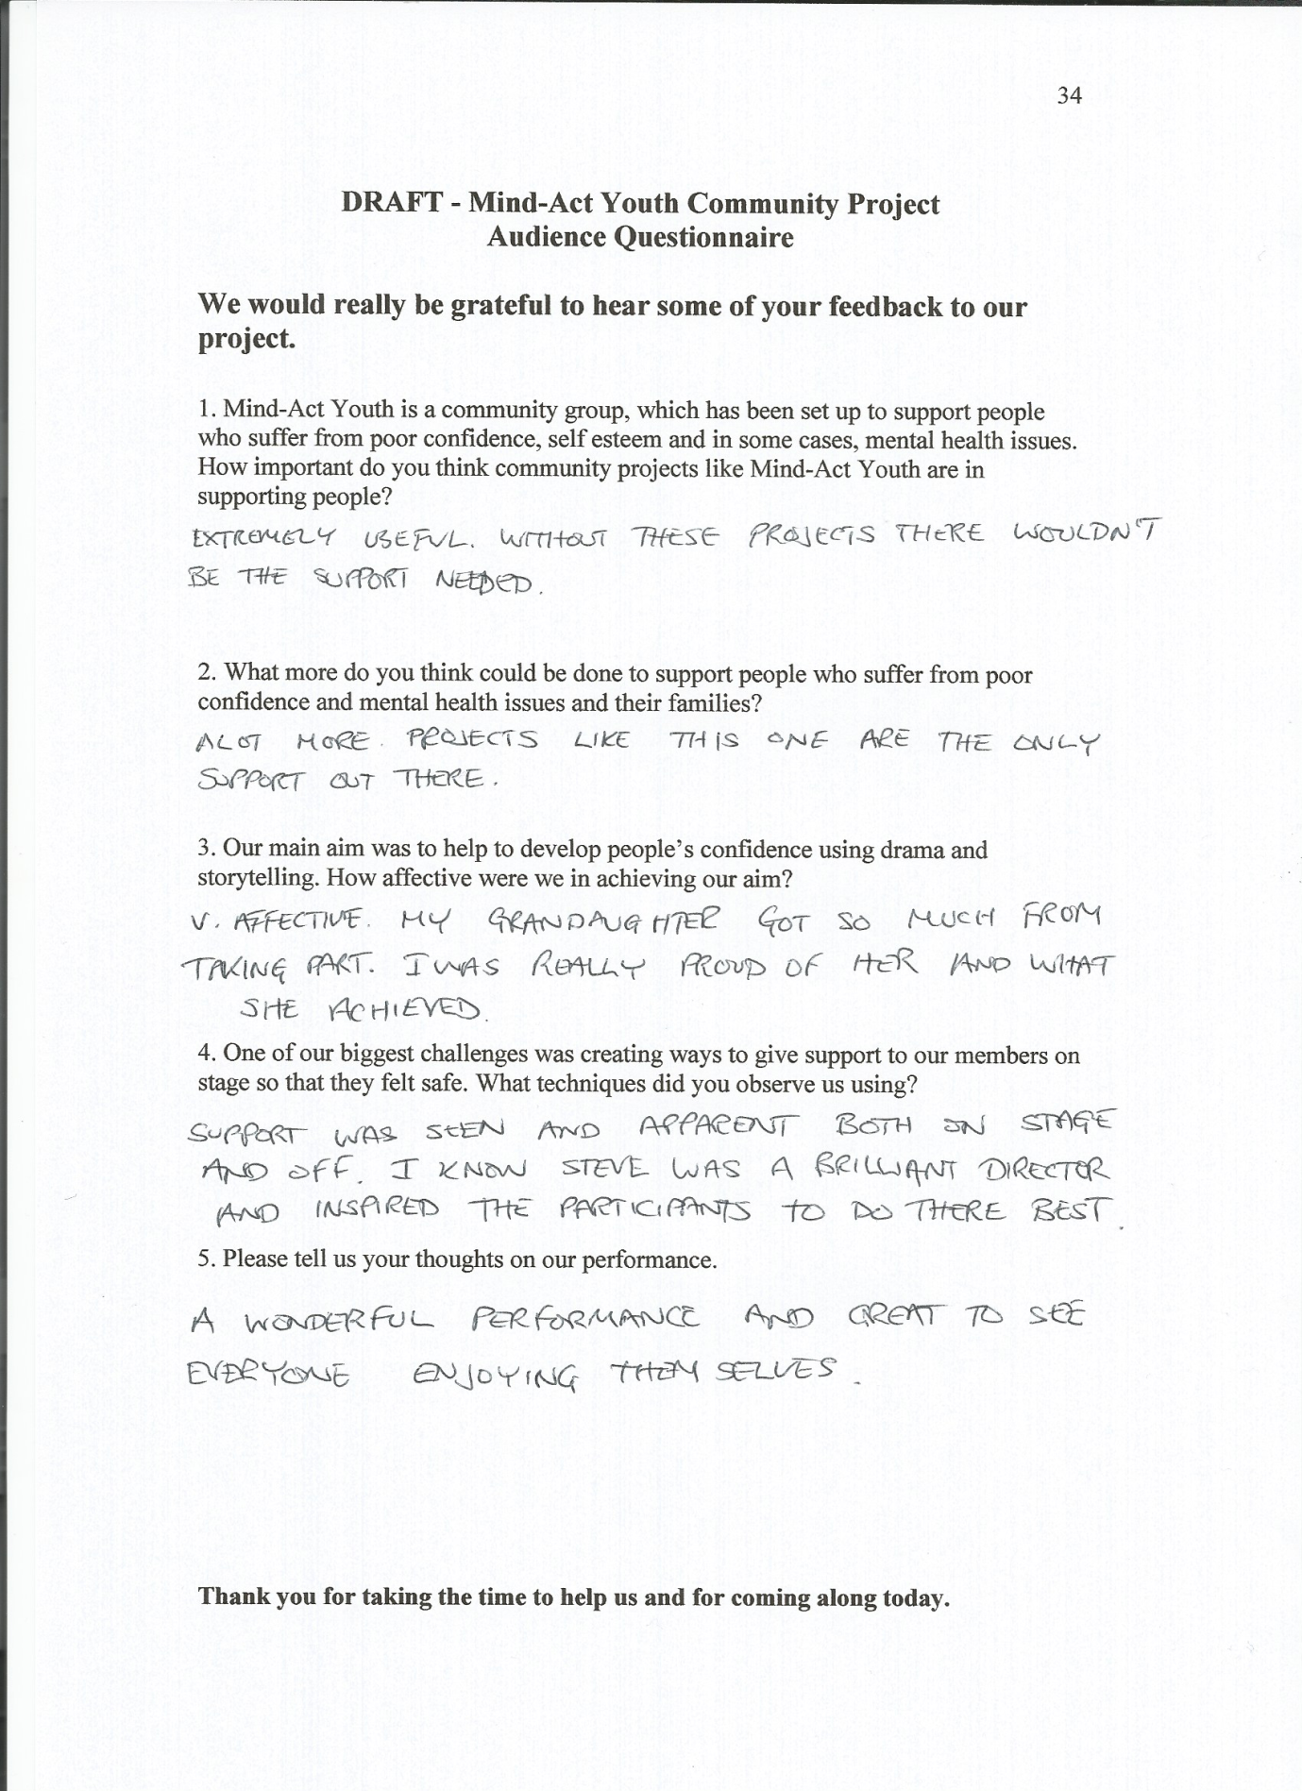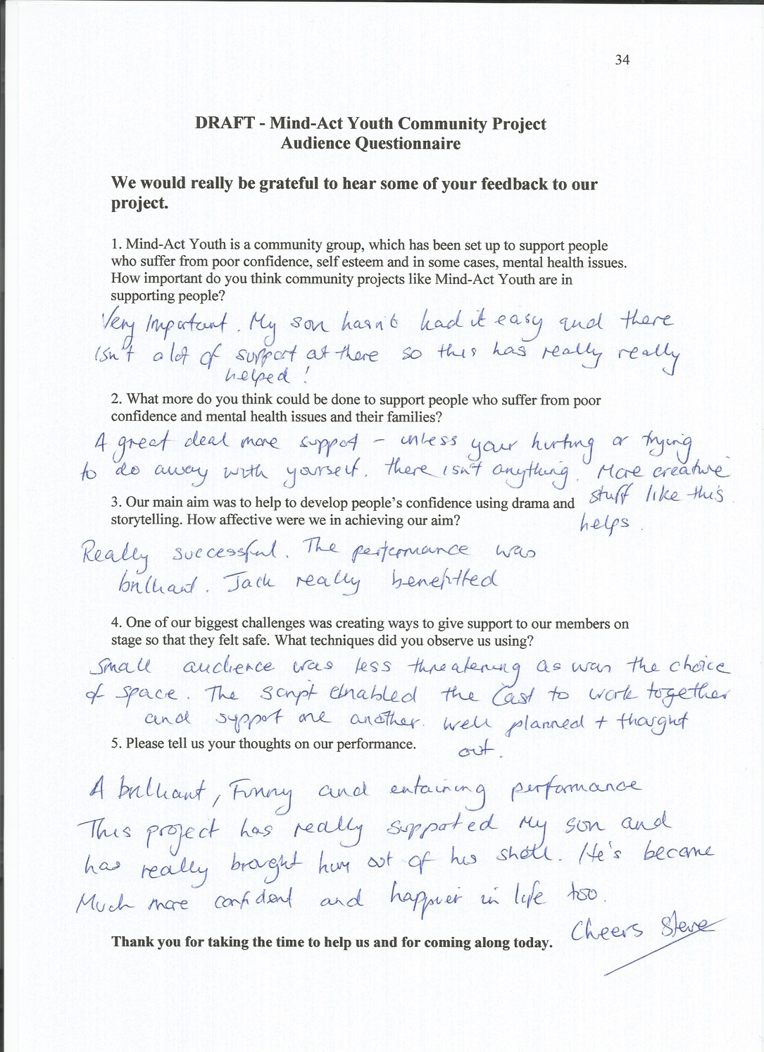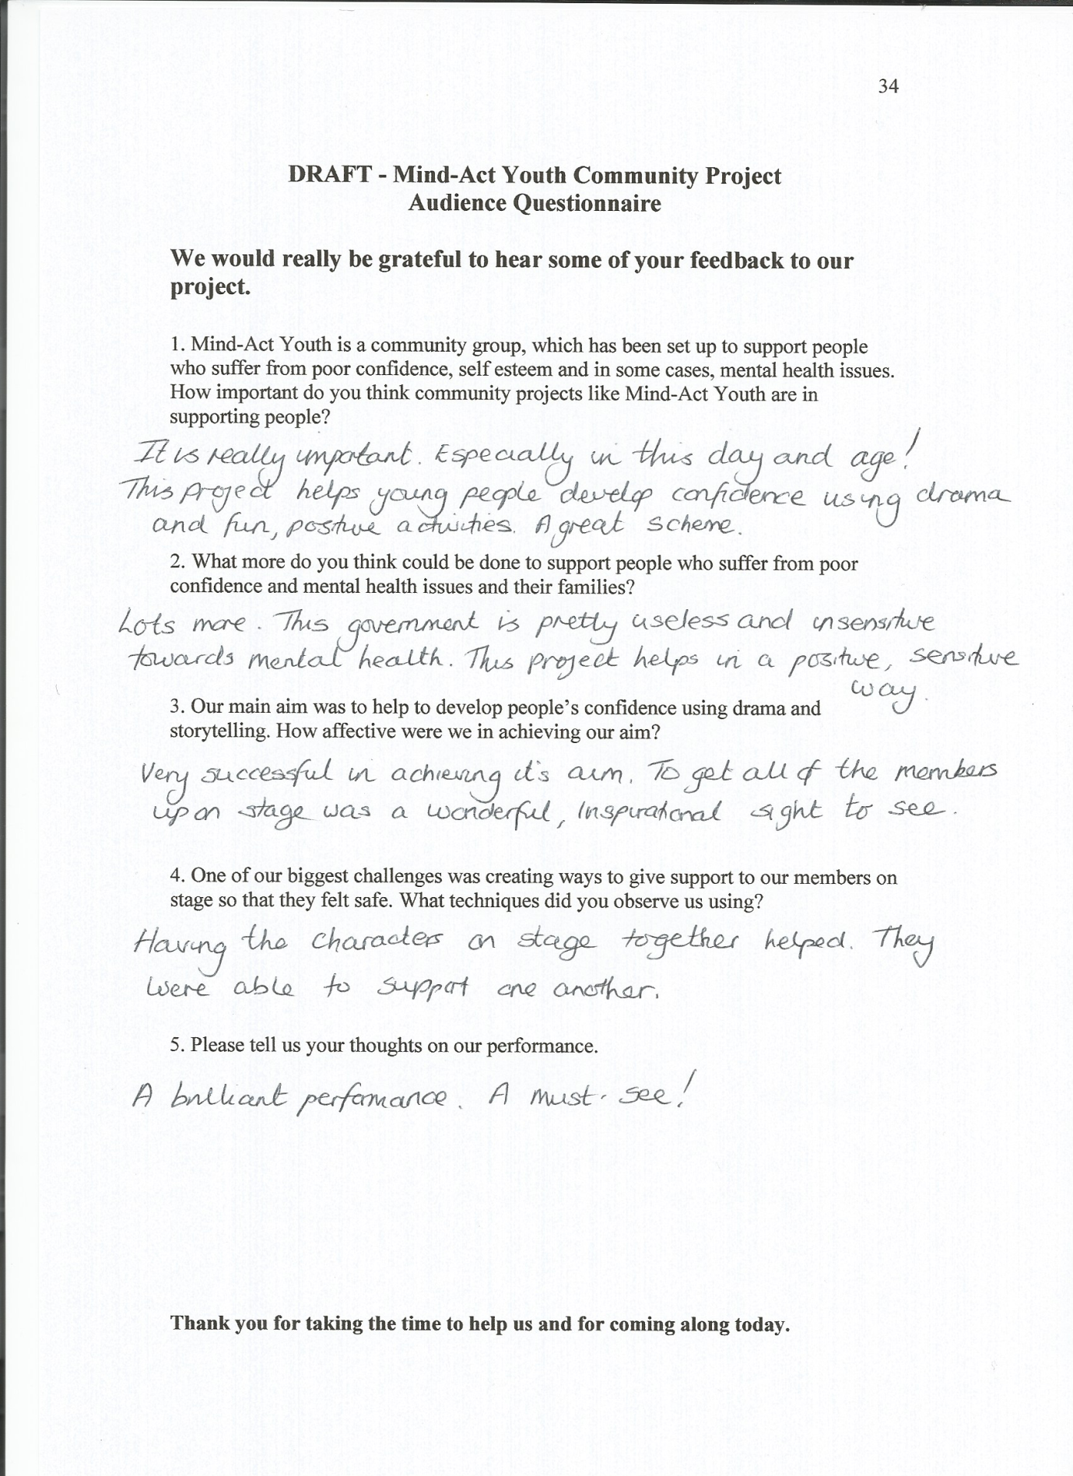

Images from our performance:

