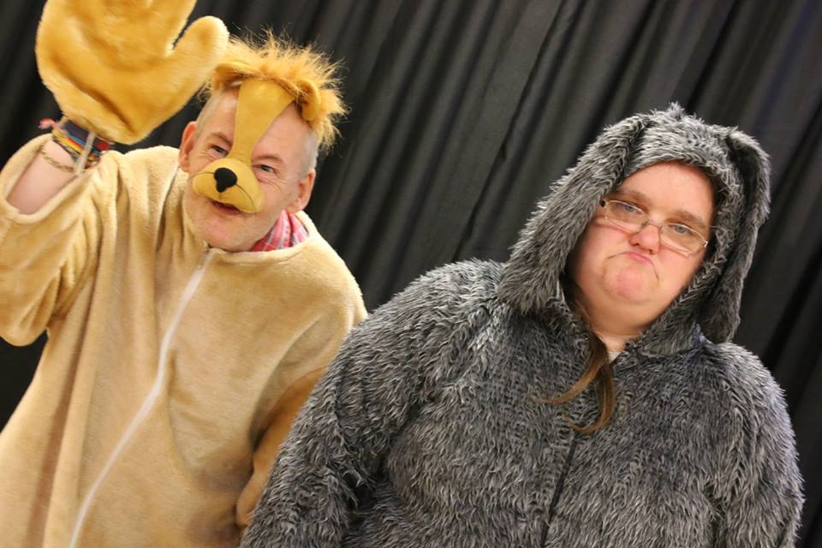

The Black Dog Theatre Creation
Living Wild Community Project:
Evaluation

Overview:
The Black Dog Theatre Creation Project was set up to support a group of adults who suffer from mental health issues and poor confidence and self-esteem. The project set out to use drama and performance skills to develop their confidence and to give them a sense of positive well-being and self-belief.

What did we set out to do in this project?
The projects core aim is to “use performance techniques to support people with low confidence and mental health problems.” It has a clear vision where we believe that performance techniques can be used as a powerful tool to support the community. For the past 4 years the project has become successfully embedded within Colchester and surrounding areas, producing weekly workshops and regular performances. Last year we worked with the Puppet Soup Theatre Company and we now want to incorporate these skills by teaming up with the Essex Wildlife Trust to produce the group’s first open-air theatre show. Named the “Living Wild” Community Theatre Project, it will be open to both our existing and new participants. They will be invited to attend weekly workshops to develop confidence and positive wellbeing through performance techniques and puppetry techniques as well as developing an understanding of local wildlife. The second part of the project will then be used to develop a devised theatrical piece using puppets based on teaching others about the importance of looking after local wildlife and their habitats. The short piece will be performed outdoors to visitors at the Fingringhoe Wick Wildlife Trust site. As well as creating our performance, we will also create opportunities for our audiences to meet and greet our puppets and learn how they were made. Participants will:
1. Applied learning to produce a puppetry experience for others.
2. Created an open-air performance.
3. Developed a new working partnership with the Essex Wildlife Trust.
4. Used performance to raise awareness of local wildlife and their habitats.
5. Used performances techniques to develop confidence, positive wellbeing.

What happened?
With the continued support from both the Arts Council and Tesco’s Bags for Life, we were able to develop an exciting 6-month project working alongside the Essex Wildlife Trust. We ran over 24 successful weekly workshops at both our local community hall and our local Essex Wildlife visitor centres developing both performance skills, soft core skills such as confidence and an understanding of local habitats and wildlife conservation. The project was a big success and our members thoroughly enjoyed the experience and gained a lot from taking part. The project gave us an opportunity to further develop our work using puppets on stage and in this case, as a tool to target a family audience. In this project, we also got to develop our first outdoor performance which prove to more difficult than first thought but was a wonderful learning experience and one which we now would love to repeat again in the future. In this project, the participants also worked to further develop their confidence through acting and performance techniques. The participants became more confident in using music on stage and developing their storytelling skills through comedy and acting.

The aims of the project
Whilst continuing to develop the project, we also further developed our aims and outcomes in our project:

- Applied learning to produce a puppetry experience for others

-We worked with the Puppet Soup Theatre Company learning how to use puppets on stage exploring the relationship between the performer and the puppet and then the audience.
-We worked together using puppets in our workshops to further develop confidence, independence, positive thinking and healthy well-being.
-We explored ways of creating characters to go with our puppets and how we could apply these in performances.
-Devised a performance which used puppetry to tell a story.

- Created an open-air performance.

-Developed further performance skills needed in creating an outdoor performance e.g. use of voice projection
-Visited and planned a performance at the Essex Wildlife Visitor Centre.
-Explored ways of utilizing the space outside and using a minimal set and staging.
-Created a picnic audience set up encouraging audience members to bring a picnic, blankets and outdoor chairs to sit on.
-Created ways of changing scenes without the use of stage lighting or a stage curtain.
-Incorporated our past learnt skills of using percussion instruments and music and songs to instead of audio sound effects.
-Used the site to develop an intimate street-like performance where the audience felt involved in order not to lose their attention

- Developed a new working partnership with the Essex Wildlife Trust.

-Essex Wildlife Trust ran several workshops for us at their visitor centres developing an understanding of habitats and local conservation.
-Working with Essex Wildlife Trust gave us a brand-new focus point and challenge which was a wonderful experience.
-Essex Wildlife Trust supported our public engagement strategy by helping us to open the project up to new members.
-By creating a performance at the Essex Wildlife Trust Visitor Centre, we were able to develop a new audience raising awareness of our project to more people locally and further afield.
-We made several visits using the outdoor spaces to rehearse, to visit, socialise and to meet new people.
-Essex Wildlife Trust provided support in networking and reaching larger audiences through social media.

- Used performance to raise awareness of local wildlife and their habitats.

-As a group we took part in workshops and visits where we learnt more about local habitats and wildlife and the issues facing conservation.
-We successfully devised our own performance which raised awareness of the issues facing local wildlife and how we as a community can support local wildlife.
-The group and audience members reported back feeling a greater appreciation towards local wildlife conservation and the Essex Wildlife Trust visitor centres as places to visit.

- Used performances techniques to develop confidence, positive wellbeing.

- 100% of our members reported back in our evaluation workshop as to feeling more confident because of the project.
- 100% of our members reported back as to feeling less isolated because of the project.
- All our members felt that they had become more positive and social because of the project.
- Family members of our members fed back to us in questionnaires as feeling that relationships had strengthened because of the project and that they had developed a greater understanding of the issues of mental health.
- All our members felt that by creating a performance it gave them something positive to work towards and to achieve.
- All our members felt that they had learnt new artistic skills.
- Our members felt that they had become stronger communicators and had developed ways of coping with low moods through the performance skills.

What didn’t work well?

Sadly, our project was slightly hindered by the local council cutting the main bus route to/from our workshop venue which affected quite a few of our members. We were able to overcome this by piling on more support and finding new routes and methods of transport. We have also been offered a new workshop venue at the Colchester Volunteer Centre for our future projects which is in the centre of Colchester which has easy access via both buses and train services. The centre itself has car parking too.

Next Steps for the project:

We would like to next:

-Further develop our partnership with the Essex Wildlife Trust by developing another production with their focusing upon raising awareness of local habitats through a range of different performance techniques.
-Our members have expressed an interest in exploring the art of spoken word and poetry in performance next.
-We would like to develop more opportunities to visit the local theatres.
-We would like to strengthen our link with Rethink Mental Health charity.
-We would like to work with the Colchester Volunteer Centre to develop more opportunities for volunteers to get involved in the project.
-We would like to create a new short documentary film about the group to help to promote the group further.
-We would like to move the group to the Colchester Volunteer Centre to ensure that the project remains fully accessible.

Feedback from our audience & members:

“Both my husband, two daughters and I thoroughly enjoyed the performance. It was a lovely day out.” (Jenny Causeway, Audience member)

“This was my project with the Black Dog Theatre group. It has boosted my confidence so much and I feel more positive.” (Margret, member)

“Working with the Essex Wildlife Trust has been so much fun. We’ve all enjoyed our visits and performing there.” (Peter, member)

“I loved the puppets and the Deer. She was dead funny!” (Kirsty, aged 8, audience member)

“My wife’s confidence just keeps growing with every Black Dog project.” (David)

“The Day the Bulldozers Came was a great play for all ages. The children loved the puppets and there were also so funny jokes for the Mums and Dads too.” (Kathy Barnes, Audience)

Appendices

